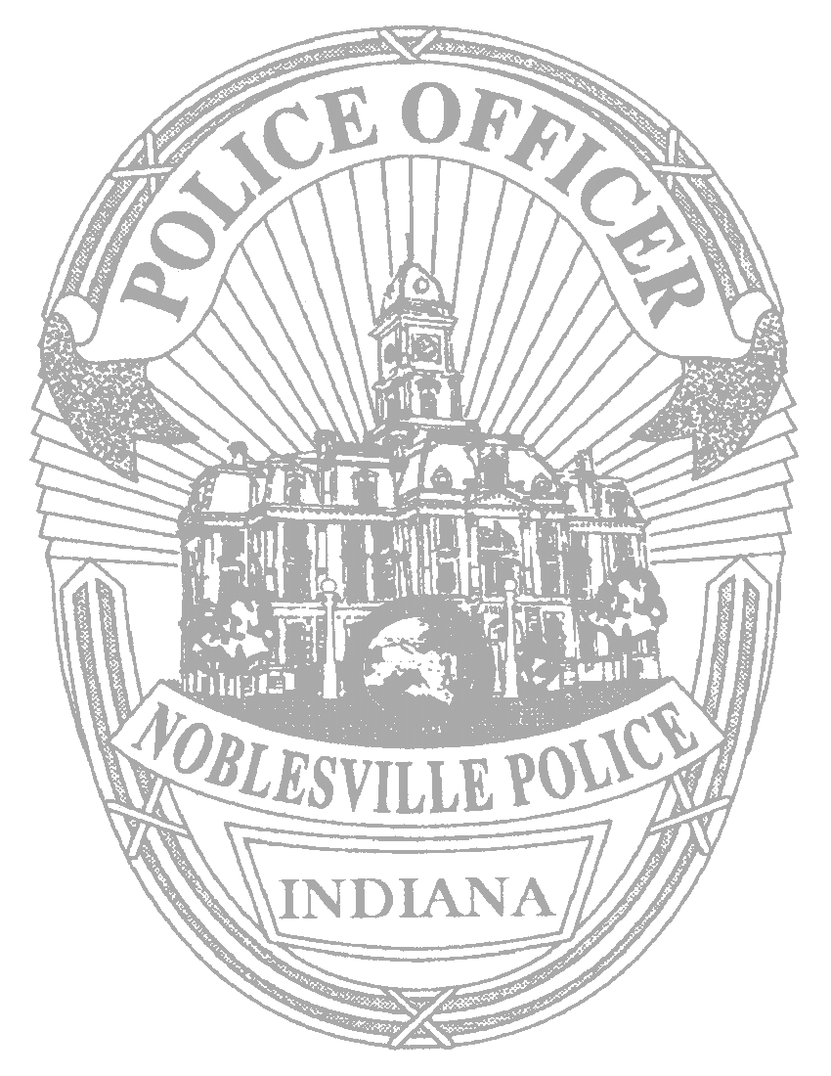

NOBLESVILLE POLICE DEPARTMENT

135 SOUTH 9th STREET
NOBLESVILLE, INDIANA 46060

Business Telephone (317) 776-6340
Explorer Post 130 Business Fax (317) 776-6388

Exploring is based on a unique and dynamic relationship between youth and the organizations in their communities. The Explorer program is a learning for life’s career education program for young men and women who are 14 (and have completed the eighth grade) or 15 -20 years old. The exploring purpose is to provide experiences to help young people mature and to prepare them to become responsible and caring adults. The Noblesville Police Department (NPD) has been actively involved in the Police Explorer Program since the early 1980’s. The program is administered by police officers who serve as counselors, mentors, leaders and provide instruction on the five (5) areas of emphasis to include career opportunities, life skills, citizenship, character educations and leadership experience. The NPD Police Explorers Program prides itself in providing a supportive, caring, and enjoyable environment for today’s youth who are tomorrow’s leaders. NPD takes it commitment to this program as well as other programs directed at the youth involvement and development serious, and the officers strive hard to provide examples of role models and mentors for the youth.

The purpose of the Noblesville Police Department Law Enforcement Exploring program is to provide young adults who may be interested in a career in law enforcement with a comprehensive program of training, competition, service and practical experiences. Character development, physical fitness and good citizenship are integral components of the overall program. Through their involvement in the program, Explorers develop an awareness of the purpose, mission and objectives of law enforcement agencies. Exploring challenges teenagers to learn about law enforcement through hands on training while providing leadership training and responsibilities. The youth that are involved in Exploring will gain practical knowledge of and experience in law enforcement, have a chance to learn and grow in a supportive, caring, and enjoyable environment, and have a chance to advance in the post from Explorer to Sergeant, Lieutenant or Captain. Explorers may qualify to receive Scholarships for college as well as individual achievement awards

NPD Explores are required to attend an annual NPD Explorer Academy (2011 dates are TBA) and monthly training sessions where they are shown most aspects of police work. Upon completion of the academy phase, the Explorer is given a uniform (pants and top; the Explorer is responsible for purchasing their own belt and boots) and allowed to ride with a police officer, observing the 911 center, and provide assistance to the department by participating in details such as traffic direction and other various community events (Hamilton County 4H Fair, parking details, etc).

Explorer meetings are schedule from 6pm to 8pm on the second and forth Monday of the month (with the exception of holiday weekends ending on a Monday). Explorers are required to attend at least four meetings per quarter.

Explorer applicants will need to fit the following requirements to participate in the program:
- Must be at least 14 yrs old and a freshman in high school – (this starts the summer after their 8th grade year)
- Must maintain a 2.0 grade point average while in school
- Must not have a criminal history of any kind – (background checks done)
- Must pass drug screen upon entry – (random test are given throughout the year)

If you are interested in participating in the Police Explorer Program please have your parent/guardian sign this form and come to a meeting.

_____________________________________
Explorer Applicant

__________________________________ _________________________________
Parent/Guardian (print and sign) Date Signed

